Learning and work context as antecedents of innovation behaviour: empirical evidence from Russian companies

Mariia Molodchik *
Department of Financial Management
National Research University of Higher School of Economics
University Address: Lebedeva str. 27; 614070; Perm campus,
E-mail: mmolodchik@hse.ru

Aleksandra Krutova
Department of Management and Marketing
Perm National Research Polytechnic University
University Address: Komsomolski str. 29, Perm, Russian Federation
E-mail: alexkrutova@yandex.ru

Anatolij Molodchik
Department of Management and Marketing
Perm National Research Polytechnic University
University Address: Komsomolski str. 29, Perm, Russian Federation
E-mail: rmc@edu.ru

* Corresponding author

Structured abstract

Purpose – The paper explores the relationship between learning process and innovation behaviour of employees in large and medium-sized manufacturing companies in Russia. The authors assume that intrinsic motivation, leadership, flexible organizational structure, culture of self-organization and self-development are supporting factors for employees’ learning.
Design/methodology/approach –The constructs for dependent and independent variables are developed drawing on a literature review. Hypotheses on casual path dependence were put forward. The model is tested on a database collected in 2013 containing the responses of 95 employees from 15 companies. The Partial Least Squares Structural Equation Modeling (PLS-SEM) technique is applied.
Originality/value – This methodology provides evidence that suggests that for Russian companies the learning process and work context are the antecedents of innovation behaviour.
Practical implications – The findings suggest that to facilitate innovation behaviour managers should build a supportive environment for learning processes. This environment should be based on intrinsic motives, encouraging leadership, self-organization and self-development principles.
Keywords – learning, work context, innovation behaviour, empirical study, Russian companies.
Paper type – Academic Research Paper

1 Introduction

A knowledge-driven economy determines innovation as a key source of competitive advantage (Nonaka and Takeuchi, 1995; Sankowska, 2013). The factors that influence innovation behaviour are investigated from a theoretical and practical point of view (Smith et al. 2008). The studies such as Scott and Bruce (1994), Saros et al. (2008) underline the holistic perspective of innovation behaviour of employees. This means that innovation behaviour is influenced by a variety of different factors, which in turn interrelate. One of the core factors which impact on innovation behaviour is learning (Sankowska, 2013). If we define innovation behaviour as a process of new knowledge creation, learning becomes a prerequisite. At the same time, the learning environment and other company building blocks that create new knowledge are essential for effective innovation (Nonaka, 1998). The authors assume that intrinsic motivation, flexible organizational structure, leadership, culture of self-organization and self-development are supporting factors for learning that precede employees’ initiative behaviour.
The main research question addressed in this study aims to find empirical evidence of a relationship between learning and innovation behaviour, taking into account work context. Moreover, authors explore these processes in the companies which work in the developing market. According to Jamali and Sidani (2008) the field of empirical exploration of learning organization in a context of developing countries is underdeveloped. Such kinds of studies contribute to the theoretical issues of learning organization as well to its practical implementation.
The paper is organized as follows. Next section presents theoretical background and hypothesis development. Section 3 is devoted to methodology and data description. Further the results of econometric modelling are analysed. And section 5 provides the conclusions and discussion.

2 Theoretical background and hypothesis development
The concept of learning organization (Senge, 1995; Pedler et al., 1997) connects innovation behaviour and learning. In line with Garvin et al. (2008) and Holsapple and Singh (2005), the authors emphasize the significance of work context as an enhancer of and mediator between learning and innovation in a company. The research design of this study includes identifying four exogenous constructs: supporting elements for learning – motivation system, organizational structure, leadership and organizational culture. And two endogenous constructs: learning and innovation behaviour of employees. Figure 1 presents the proposed model.
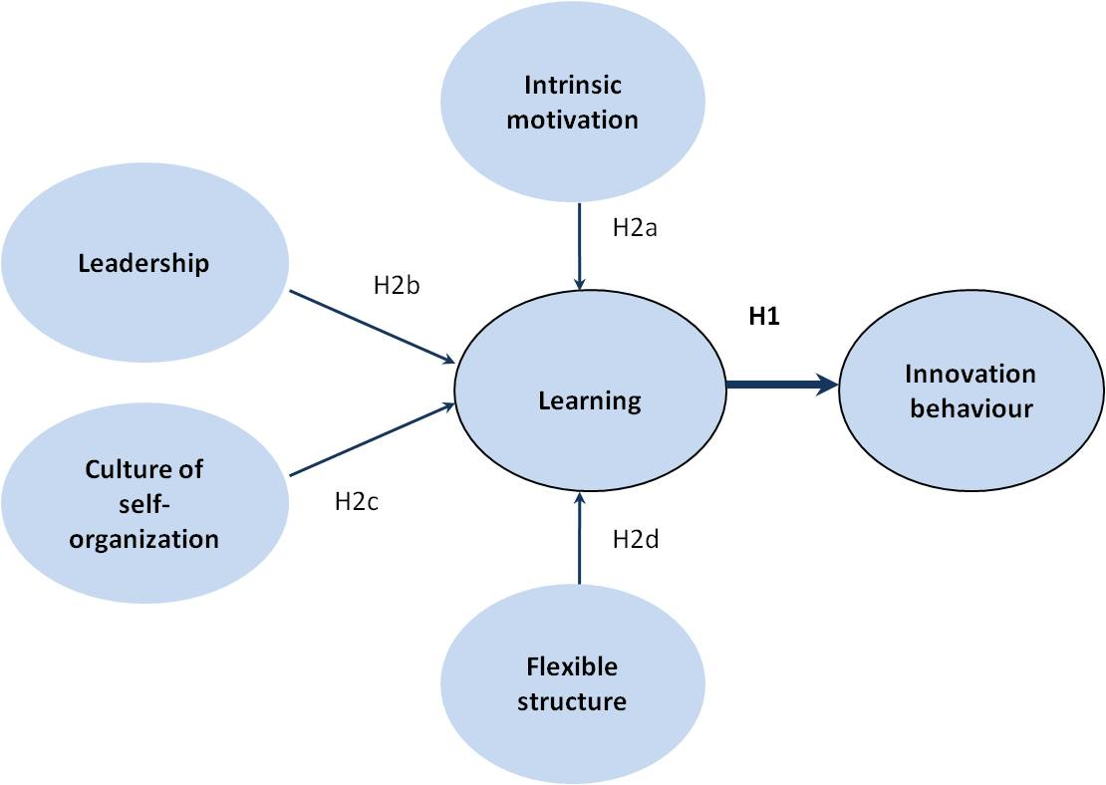
Figure 1. Framework of research
Innovation behaviour
This study considers innovation behaviour as employee activities directed at improving products and services as well as implementing new management tools and work techniques and excelling in knowledge creation in a wide sense. The motivation to innovate is influenced by learning, management style, organizational structure, available resources, organizational culture and corporate strategy (Scott and Bruce, 1994; Smith et al., 2008).
Learning
The main characteristic of a learning organization is that learning processes are mandatory and on-going. Such organizations invest continuously in training and upgrading of individual and organizational skills. Knowledge is transferred between individuals, groups, and departments effectively and on a voluntary basis. The organization constantly identifies and accesses new external and internal opportunities, developing dynamic capabilities.
The main hypothesis tested in this study is:
H1: Learning has a significantly positive effect on innovation behaviour.
The next factors help create an environment that is supportive of the learning process. The second group of hypotheses reflect the relationship between different factors and learning.
Intrinsic motivation
Theoretically, there exists both intrinsic and extrinsic motivation (Deci and Ryan, 1985). The first means that motives are internal to the employee and that there is a self-evaluation mechanism at work. Intrinsic task motivation is achieved through: (1) meaning, i.e., value of work goal or purpose, competence, and self-determination; (2) autonomy in the initiation and continuation of work; and (3) impact, where employees influence work results (Thomas and Velthouse, 1990). The literature supports the view that employees who are empowered, self-determined and intrinsically motivated have a greater degree of willingness to learn. The authors put forward the following hypothesis:
H2a: Intrinsic motivation is positively related to learning.
Leadership
Leadership is an essential element of a learning organization (Holsapple and Singh, 2005). As noted by Garvin et al. (2008) organizational learning is strongly influenced by the behaviour of leaders. Leaders in learning organizations inspire people to accomplish extraordinary results by applying charismatic leadership, creating larger-than-life mindsets, inspiring everyone to do their best, and mobilizing individual initiative (Garvin et al., 2008). More level leadership is developed through cultivating internal leaders by encouraging people to become leaders, filling positions with internal talent, and promoting from within. Such leaders stimulate change and improvement by continuously striving for self-awareness and renewal and developing dynamic managerial capabilities to enhance flexibility. The next hypothesis is:
H2b: Leadership is positively related to learning.
Culture of self-organization and self-development
The principles of self-organization and self-development suppose that an organization fosters individual growth and achievement by developing self-reliance and encouraging learning, probing, and discovering. Such a culture makes people feel that they are part of a bigger thing, and inspires them to achieve greatness; it instils in employees a sense of confidence, collective will, can-do attitude, and emotional energy (Chang and Lee, 2007). Employees have a shared strategic vision. The empirical findings of Jamali and Sidani (2008) confirmed that in developing countries culture of self-organization plays a pivotal role for learning process. In the framework of this study the following hypothesis is put forward:
H2c: Culture of self-organization and self-development is positively related to learning.
Flexible organizational structure
The organizational structure determines the flexibility of business processes, the speed and quality of knowledge transfer, the possibility of the creation of new structural units and project development. The traditional organizational hierarchy should be broken down, establishing an agile organizational structure. Such a structure is characterized by highly transparent communication networks, clear rules for initiative implementation and resource distribution. All this enables an organization to be better in problem solving, experimentation and organizational learning (Holsapple and Singh, 2005). The last hypothesis is:
H2d: Flexible organizational structure is positively related to learning.
As mentioned by Garvin et al. (2008), a lack of empirical studies and concrete practical prescriptions on learning organizations impedes the development of this concept. This paper contributes to the empirical analysis of learning roles for innovation behaviour, taking into account the environmental factors that support or obstruct this link.

3 Methodology and data
For econometric justification of the hypotheses, the authors implement PLS-SEM analysis. This technique allows building the unobservable and hard-to-measure latent variables; and visually examines the relationships that exist among variables of interest. (Ringle et al., 2005). According to Hwang et al. (2010) and Wong (2010) PLS-SEM is proposed for application when a sample is small and there is little available theory. This study faces both restrictions; consequently PLS-SEM technique was chosen. The authors used Smart PLS software which is freely available to the research community across the globe and has been deployed in many fields, such behavioural science, marketing, organization and business strategy (Wong, 2013).
The empirical data consist of questionnaire responses of 95 employees from 15 Russian medium- and large-sized companies. Among the respondents 64% were male and 36% female; the distribution according to their position was as follows: 43% - top-manager; 34% - middle managers; 23% - specialists; 62% of respondents work in the company more than three years. All companies were from manufacturing industry. Data were collected in 2013.
The questionnaire was developed considering the previous studies of Watkins and Marsick (1998), Garvin et al. (2008), Jamali and Sidani (2008), and Galisir et al. (2013). Learning activities and work context were measured questioning employees about the appearance of each item in their practice, on a scale ranging from 1 (does not appear) to 5 (appears very often). Questionnaires to measure innovation initiative had a scale from 1 to 5 as well. For all latent constructs depicted on the figure 1 the items (questions) were developed. Initially the questionnaire contains 60 items (questions), but after several iterations the constructs included in the model were described through 33 items. Table 1 presents items for each latent variable as well as values of item reliability.
Table 1. Latent construct and item reliability
Latent variable | Items | Loadings | Item reliability
Innovation behaviour | In my organization people frequently discuss and initiate the improvement of their work | 0.877 | 0.769
 | In my organization people frequently experiment with new ways of working | 0.859 | 0.737
 | In my organization people initiate the implementation of new ways of working | 0.830 | 0.688
 | In my organization people initiate experiments and development regarding new products or service offerings | 0.762 | 0.580
 | In my organization people learn new requirements, standards, rules without assistance | 0.840 | 0.706
 | In my organization people solve conflicts and establish effective communication without assistance | 0.777 | 0.604
Learning | My organization identifies, develops and retains talented employees | 0.851 | 0.723
 | In my organization people help each other learn | 0.773 | 0.597
 | In my organization people are eager to share information and experience | 0.817 | 0.668
 | In my organization leaders generally support requests for learning opportunities and training | 0.802 | 0.643
 | My organization frequently compares its performance with that of competitors and best-in-class organizations | 0.789 | 0.622
 | The best practice of one department quickly diffuses within the organization | 0.640 | 0.410
Intrinsic motivation | In my organization people are eager to solve new, atypical problems | 0.702 | 0.493
 | In my organization people demonstrate the willingness to participate in team-work | 0.760 | 0.578
 | In my organization people attempt to achieve best results even to the detriment of personal interests | 0.872 | 0.761
 | In my organization people are ready to use private time for education and training | 0.853 | 0.728
 | In my organization people are able to achieve results with minimum external intervention | 0.783 | 0.613
Culture based on self-organization and self-development | My organization invites people to contribute to the development of strategy | 0.665 | 0.442
 | My organization builds alignment of visions across different levels | 0.777 | 0.604
 | In my organization learning and self-development are valued | 0.896 | 0.803
 | My organization supports and rewards team-work | 0.921 | 0.848
 | My organization encourages initiative and objective-oriented behaviour | 0.870 | 0.756
Leadership | Managers effectively exhibit the role of mentor and coacher | 0.748 | 0.559
 | In my organization leaders inspire others to accomplish extraordinary results | 0.875 | 0.765
 | Managers encourage multiple points of view | 0.910 | 0.827
 | Managers provide time, resources, and venues for identifying problems and organizational challenges | 0.822 | 0.676
 | Leaders acknowledge their own limitations with respect to knowledge, information or expertise | 0.773 | 0.597
 | Leaders are the example of entrepreneurial and self-development behaviour | 0.841 | 0.707
Flexible organizational structure | Organizational structure facilitates more equal leadership | 0.713 | 0.508
 | New units, departments and projects can be launched quickly | 0.827 | 0.684
 | Managers delegate authority and decision-making | 0.753 | 0.567
 | My organization provides resources for innovation initiatives and projects | 0.800 | 0.640
 | Clear and transparent regulations support implementation of innovation initiatives | 0.793 | 0.628

As we can see, all of the indicators have individual item reliability values that are larger than the minimum acceptable level of 0.4, and most of them are close to the preferred level of 0.7. All reflective latent variables show high levels of internal consistency reliability. The value of composite reliability for all variables is larger than 0.6. To check convergent validity, each latent variable’s Average Variance Extracted (AVE) was evaluated. All of the AVE values are greater than the acceptable threshold of 0.5, so convergent validity is confirmed (Wong, 2013).

4 Results
In the framework of this study several models were tested using the smart PLS program. The authors chose the best model to explain casual path dependencies among the above-presented variables. The criteria of selection were the level of significance of each path and the explanation power of dependent variable. Figure 2 visualised the results obtained in this study.
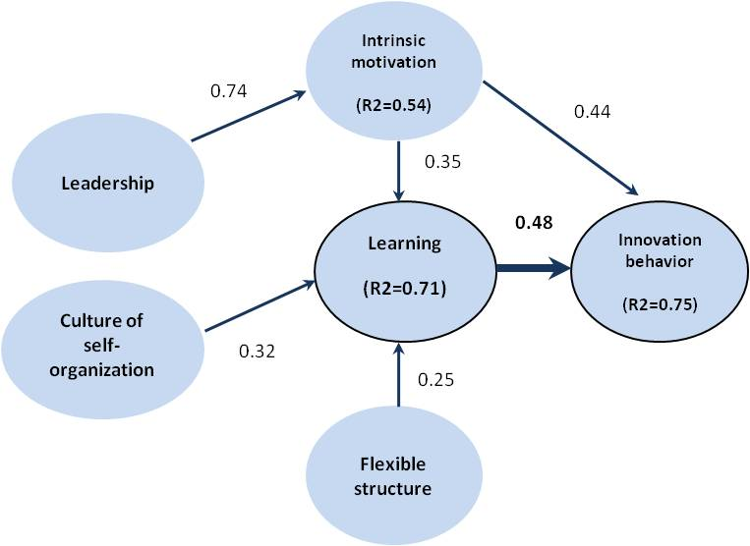
Figure 2. Results of PLS-analysis
The implemented methodology provides evidence for the positive impact of learning on the innovation initiative of employees. This fact is reflected in the positive and significant coefficient – 0.48. The first hypothesis is confirmed.
Contrary to our expectations, not all factors influence learning directly. As we can see in Figure 2, a flexible organizational structure as well as a culture based on self-organization and self-development principles have a significant positive impact on learning; intrinsic motivation has a significant positive influence on both innovation behaviour and learning. Leadership influences learning indirectly through intrinsic motivation.
Learning and intrinsic motivations explain 75% of the variance in the endogenous latent-variable innovation initiative, which is substantial. Meanwhile, intrinsic motivation, flexible organizational structure, culture of self-organization and self-development explain 71% of the variance in learning. Leadership determines 54% of the variance in intrinsic motivation. The structural path significance was checked with the bootstrapping procedure. All indicators (see Table 2) show t-statistics larger than 1.96, which means the values are highly significant.
Table 2. Results of checking structural path significance
 | Original sample (O) | Sample mean (M) | Standard deviation (STDEV) | Standard error (STERR) | T statistics (|O/STERR|)
Learning -> innovation behaviour | 0.48 | 0.4852 | 0.05 | 0.05 | 9.6721
Motivation -> innovation behaviour | 0.43 | 0.436 | 0.0514 | 0.0514 | 8.5021
Leadership -> motivation | 0.74 | 0.7375 | 0.0182 | 0.0182 | 40.3165
Motivation -> learning | 0.35 | 0.3534 | 0.0362 | 0.0362 | 9.7666
Culture -> learning | 0.32 | 0.3182 | 0.0461 | 0.0461 | 6.8903
Structure -> learning | 0.25 | 0.247 | 0.0452 | 0.0452 | 5.4464

5 Conclusions
The study contributes empirical evidence on the implications of learning-organization principles in developing countries. It extends the ideas of Watkins and Marsick (1998) and Pedler et al. (1997), investigating learning-organization mechanisms and their impact on a company’s innovation (Galisir et al., 2013) in practice.
The findings of this study confirm the pivotal role of learning for innovation in the context of developing markets. Moreover, the authors justify empirically that more equal leadership, self-involvement, self-development, intrinsic motivation, decentralization and a more agile organizational structure are essential for the creation of new knowledge. The findings extend the results obtained for developing markets by Calisir et al. (2013) and Fernández-Mesa et al. (2013), confirming the hypothesis of the positive impact of learning as well as work context on a company’s innovation. The authors consider the potential value of the presented study to be twofold: firstly, the methodology provides a questionnaire which is adapted from English into Russian and allows further exploration of Russian companies; secondly, the study provides unique empirical evidence of the enabling of innovation for Russian companies through learning and work contexts. The outcomes are expressed in practical recommendations for managers to build learning organizations by designing and implementing organizational learning mechanisms.
References
Calisir F., Gumussoy C.A., Guzelsoy E. (2013) “Impacts of learning orientation on product innovation performance”, Learning Organization, The, Vol. 20, Iss. 3, pp.176–194
Chang S.-C., Lee, M.-S. (2007) “A study on relationship among leadership, organizational culture, the operation of learning organization and employees’ job satisfaction”, Learning Organization, The, Vol. 14, No. 2, pp. 155-185
Deci, E.L. and Ryan R.M. (1985) Intrinsic motivation and self-determination in human behaviour. New York: Plenum Press
Fernández-Mesa A., Alegre-Vidal J., Chiva-Gómez R., Gutiérrez-Gracia A. (2013) “Design management capability and product innovation in SMEs”, Management Decision, Vol. 51, Iss. 3, pp. 547–565
Jamali D. and Sidani Y. (2008) “Learning organizations: diagnosis and measurement in a developing country context. The case of Lebanon”, Learning Organization, The, Vol. 15, Iss. 1, pp. 58–74
Holsapple, C.W. and Singh, M. (2005), “The knowledge chain model: activities for competitiveness”, in Handbook on Knowledge Management, Vol. 2, Springer Science & Business Media B.V.
Hwang, H., Malhotra, N.K., Kim, Y., Tomiuk, M.A. and Hong S. (2010) “A comparative study on parameter recovery of three approaches to structural equation modelling”, Journal of Marketing Research, Vol. 47, pp. 699-712
Nonaka, I. (1998), “The concept of ba: building a foundation of knowledge creation”, California Management Review, Vol. 40, No. 3, pp. 40–54
Nonaka, I. and Takeuchi, H. (1995) The Knowledge-creating Company: How Japanese Companies Create the Dynamics of Innovation, New York: Oxford University Press
Pedler, M., Burgoyne, J. and Boydell, T. (1997) The Learning Company: A Strategy for Sustainable Development, London: McGraw-Hill
Ringle, C., Wende, S. and Will, S. (2005) “SmartPLS 2.0 (M3) beta”, Smart PLS Hamburg, available at: www.smartpls.de (accessed 21 September 2013)
Sankowska, A. (2013) “Relationships between organizational trust, knowledge transfer, knowledge creation, and firms’ innovativeness”, Learning Organization, The, Vol. 20, No. 1, pp. 85–100
Sarros, J.C., Cooper, B. K., Santora J.C., (2008) “Building a Climate for Innovation through Transformational Leadership and Organizational Culture”, Journal of Leadership & Organizational Studies, Vol.15, No. 2, pp. 145-158
Smith, M., Busi, M., Ball, P., Meer, R. (2008) “Factors influencing an organization’s ability to manage innovation: a structured literature review and conceptual model”, International Journal of Innovation management, Vol. 12, No. 4, pp. 665–676
Scott, S.,G. and Bruce R., A. (1994) “Determinants of Innovative Behaviour: A Path Modle of Individual Innovation in the Workplace”, Academy of Management Journal 37, No. 3, pp. 580-607
Thomas, K.W. and Velthouse, B.A. (1990), “Cognitive elements of empowerment: An ‘interpretive’ model of intrinsic task motivation”, Academy of Management Review, Vol. 15, pp. 666–681
Watkins, K.E. and Marsick, V.J. (1996) In Action: Creating the Learning Organization, Alexandria, VA: American Society for Training and Development
Wong, K. K. (2010) “Handling small survey sample size and skewed dataset with partial least square path modelling”, The Magazine of the Marketing Research and Intelligence Association, pp. 20-23
Wong, K.K. (2013) “Partial Least Squares Structural Equation Modeling (PLS-SEM) Techniques Using SmartPLS”, Marketing Bulletin, 2013, No. 24 Technical Note 1, available at http://marketing-bulletin.massey.ac.nz

Acknowledgements: This study comprises research findings from the «Intangible-driven dynamics in economics and finance» carried out within International Laboratory of Intangible-driven Economy (ID Lab) of the National Research University Higher School of Economics’ Basic Research Program in 2014; and

